
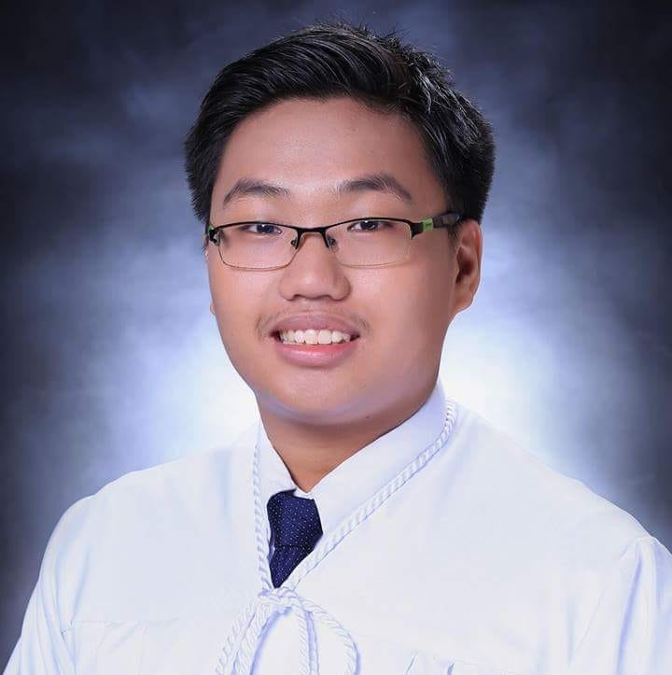
ONG MARK STANLEY N.
104 T Jacinto Caloocan city
(02) 355 -4362
629452595259

OBJECTIVE
To join an organization where I can use my skills in personnel administration and attain a high level of performance in personnel recruitment and training.

EDUCATION

Click de la salle university
Bachelor of Science in Mechanical Engineering with specialization in Mechatronics Engineering, September 2018

Click PHILIPPINE INSTITUTE OF QUEZON CITY
High School Diploma, April 2008. Honorable Mention. Awards: Most Outstanding Student, 2018.

WORK EXPERIENCE

January 2018 Green cross .inc
Assisted in checking the machine if it’s working effectively.

January 2018
Handled the accounts of new customers and advised them on their financial endeavors.

Ong Mark Stanley N.
page 2

SEMINARS ATTENDED

Nov 2017 Career talk
Philippine Institute of Quezon City

Jan 2018 LEADERSHIP SEMINAR
Philippine Institute of Quezon City

Feb 2018 EFFECTIVE PRESENTATION SKILLS SEMINAR
Philippine Institute of Quezon City

RESEARCH PAPERS PREPARED

March 2017 IPAD AS AN EFFECTIVE LEARNING TOOL
To see if implementing of gadgets in school can increase the grades or academic performance of students

March 2018 CALAMANSI PEELS AS AN ACTIVATED CARBON
Using calamansi peels as an acticated carbon in cleaning the contaminated water to increase population of using safe water

March 2018 IMPROVING STUDENT RETENTION: SATISFACTION OF STUDENTS IN ACADEMIC AND NON ACADEMIC ACTIVITIES
To see if what to improve so that students will continue to stay in school.

PERSONAL BACKGROUND

Can speak in English, Chinese, Fokien and Filipino. Interests: puzzle solving. Adaptable, Hardworking and very patience

REFERENCES
Juan Carlos Bautista
Friend
0927 280 8041
73 Roosevelt Avenue, San Francisco Del Monte, Quezon City Quezon City Second District, Roosevelt Ave, San Francisco del Monte, Quezon City, Metro Manila

